<page_start no = 1>
<sol_start id=1>
1. 16 + 8 – (7p +3)
24–7p –3
21–7p = 0
–7p = –21
P = 3
- 3
<sol_end>

<sol_start id=2>
2. 4) No solutions
<sol_end>

<sol_start id=3>
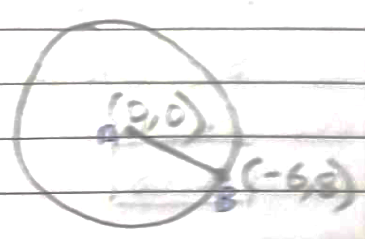
3. radius = AB
Radius = 10 units
1) 10 units
<sol_end>

<sol_start id=4>
4. 2) Proportional
<sol_end>

<sol_start id=5>
5.
Sin²30–cos²30
2)
<sol_end>
<page_end>

<page_start no = 2>
<sol_start id=6>
6. 1) x³y³
<sol_end>

<sol_start id=7>
7.
A/a
8 = 2k–8
2k = 16
k = 8
<sol_end>

<sol_start id=8>
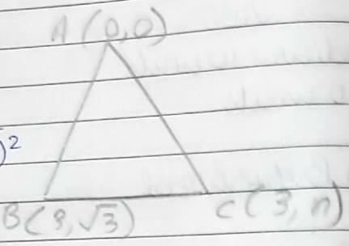
8. as ABC is equilateral,
AB = AC
x = 3
<sol_end>

<sol_start id=9>
9. For equation to have one solution,
In 2px + 3y = 7,
2x + y = 6
a, = 2p, a₂ = 2,
b, = 3, b₂ = 1
P should be 3 but can be any other number.
<sol_end>
<page_end>

<page_start no = 3>
<sol_start id=10>
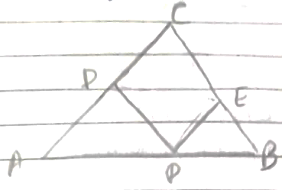
10. Given
PD||BC,
To prove,
PE||AC
Proof,
As AD||BC
[BPT] ……(i)
Also,
(given) ……(ii)
From equation (i) and (ii)
By converse of BPT,
Hence, proved.
<sol_end>

<sol_start id=11>
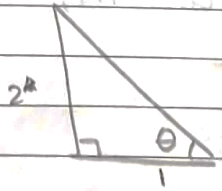
11.
So,
LHS=RHS
Hence proved
<sol_end>
<page_end>

<page_start no = 4>
<sol_start id=12>
12.
It is a terminating decimal.
<sol_end>

<sol_start id=13>
13. To prove,
is irrational,
Proof
To the contrary, lets assume
is rational it,
where a, b are co-prime
(squaring both sides)
a² is divisible by 3
so a is also divisible by 3,
Now, et a = 3m,
b² is divisible by 3,
b is also divisible by 3
This contradicts the fact that a & b are co-prime.
This contradiction occurred due to our wrong assumption.
So,
is irrational,
Hence, proved.
<sol_end>

<sol_start id=14>
14. p(x) = 2x² – 3x + 7

=
<sol_end>

<sol_start id=15>
15. For it to have infinite solutions,
3x – (a + 1)_{y} = 2b – 1
5x + (1–2a)_{y} = 3b
a₁ = 3, b₁ = (–a–1), c₁=–2b + 1
a₂ = 5, b₂ = (1–2a), c₂ = –3b
3–6a = –5a–5
8 = a
–9b = 5–10b
5 = b
<sol_end>
<page_end>

<page_start no = 5>
<sol_start id=16>
16. Given
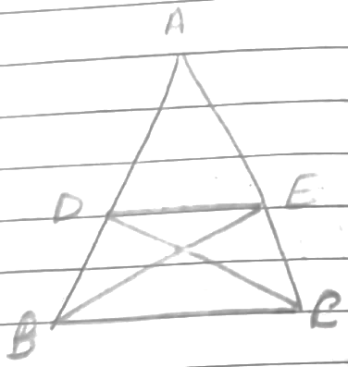
To prove
Proof,
As
In and ,
diving both eqs
(common)
By SAS
Hence, proved.
<sol_end>

<sol_start id=17>
17.
Hence, proved.
<sol_end>

<sol_start id=18>
18. Given
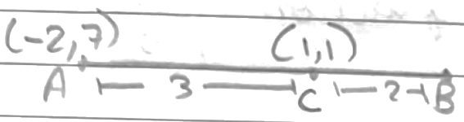
C(1, 1), A(–2, 7)
m₁ = 3, m₂ = 2,
using section formula,
1 =
5 = 3x₂ – 4
3x₂ = 9
y =
5 = 3y₂ + 14
3y₂ = –9
Coordinates of
<sol_end>

<sol_start id=19>
19. let fraction be
Given
……(i)
…….(ii)
Solving both equation
Fraction =
<sol_end>
<page_end>

<page_start no = 6>
<sol_start id=20>
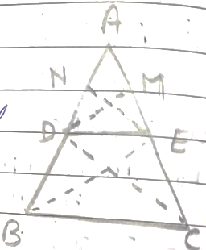
20. Thales theorem – If a line is drawn parallel to one side of triangle and intersects other two sides at distinct points then other two sides are divided in same ratio.
Given,
ABC is a triangle
DE||BC,
To prove,
Construction
Join BE and CD,
Draw and
Proof,
………(i)
………(ii)
………(iii)
[Δ’s on same base, between same parallel lines]
from eq. (i), (ii) and (iii),
Hence, proved.
<sol_end>

<sol_start id=21>
21.
= 2
<sol_end>
<page_end>

<page_start no = 7>
<sol_start id=22>
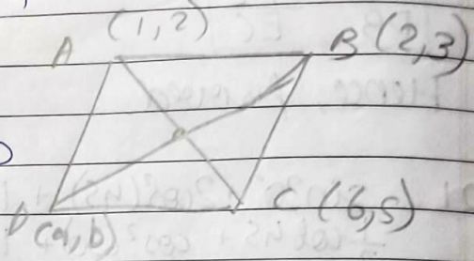
22. Join AC and BD, O is midpoint of AC & BD
So,
Midpoint of AC
↳
Midpoint of BD
↳
So as both points are same,
a = 5
b = 4
Coordinates of D = (5, 4)
<sol_end>

<sol_start id=23>
23. A will complete 1 round =
B will complete 1 round =
C will complete 1 round =
Let them meet after time t, they’ve completed n₁, n₂ & n₃ rounds, all are n dist away from start point
So,
330 t = n + 1980 n₁
198 t = n + 1980 n₂
220 t = n + 1980 n₃
↳ 198 t = 330 t – 1980 n₁ + 1980 n₂
1980(n₁–n₂) = 132 t
t = 15(n₁–n₂)
220 t = 330 t – 1980 n₁ + 1980 n₃
1980 (n₁–n₃) = 110 t
As t is same and n₁–n₃ or n₁–n₂ can be whole no,
LCM of 15, 18
= 90 min
∴ They will meet after 90 minutes.
<sol_end>

<sol_start id=24>
24. let,
Son’s age = x
Father’s age = y
A/a,
2x + y = 70 ………(i)
2y+x = 92 ………(ii)
Multiplying eq. (1) by 2 and subtracting from eq. (ii)
x = 15
Putting in eq. (ii)
2y = 80
y = 40
<sol_end>
<page_end>

<page_start no = 8>
<sol_start id=25>
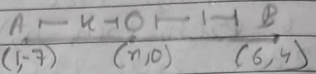
25. Using section formula,
4x – 7 = 0
ratio =
<sol_end>

<sol_start id=26>
26. m²n = (cosesθ–sinθ)2 (secθ–cosθ)
Similarly,
mn² = (cosecθ–sinθ) (secθ–cosθ)²
= 1
Hence, proved
<sol_end>

<sol_start id=27>
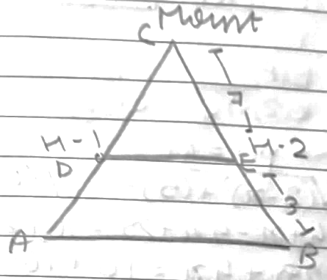
27. Clearly DE||AB,
So, In and DCE,
∠C = ∠C (common)
By SAS,
<sol_end>

<sol_start id=28>
<sub_id = 1>
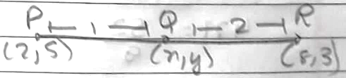
28.(i) Using section formula
= =
x = 4
= =
Coordinates of
<sub_id end>
<sub_id = 2>
(ii) PR
<sub_id end>
<sub_id = 3>
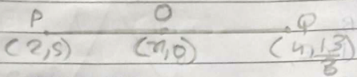
(iii)

29 + 4x = 16
13 + 4x =
x = 117
<sub_id end>
<sub_id = 4>
(iv) Midpoint of PR
<sub_id end>
<sol_end>
<page_end>

<page_start no = 9>
<sol_start id=29>
29. let speed of A = x km/hr
let speed of B = y km/hr
when traveling in same direction,
relative speed → x–y
dist = 100 km
t = 4 hr
dist = s × t
100 = (n–y)5
x–y = 20 …..(i)
when moving in opp. direction
relative speed → x + y
dist = 100 km
t = 1 hr
dist = s ×t
100 = (x = y)
x + y = 100 …..(ii)

Solving both eq
2x = 120
x = 60 km / hr
y = 40 km / hr
<sol_end>
<page_end>

